- Small Office Network

Q1. Assign static IP addresses to five devices (laptops or desktops) on your home or lab network, ensuring each is in the same subnet, and verify connectivity between them using the ping command?

Answer
- Five PCs were connected to a switch and assigned static IP addresses in the same subnet: 192.168.1.10 to 192.168.1.14 with subnet mask 255.255.255.0.
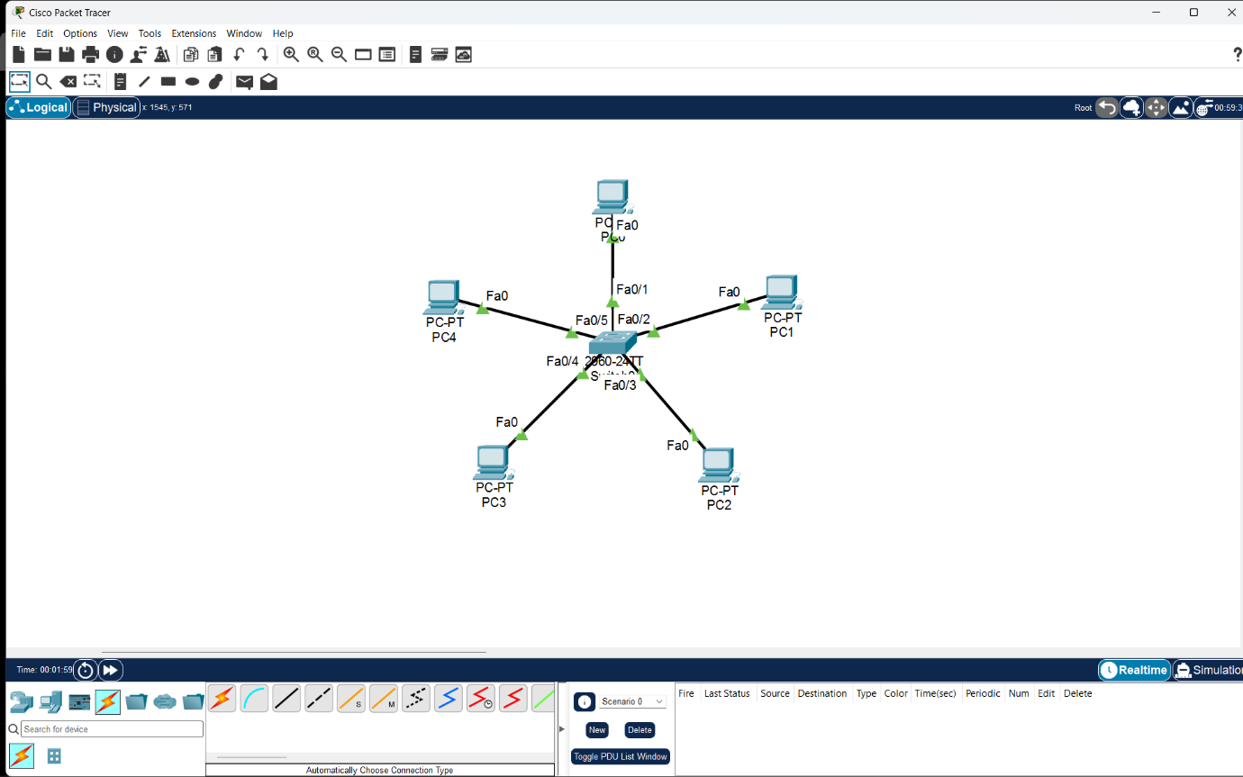
- Connectivity was tested using the ping command. All devices replied successfully with 0% packet loss, confirming that they could communicate with each other.

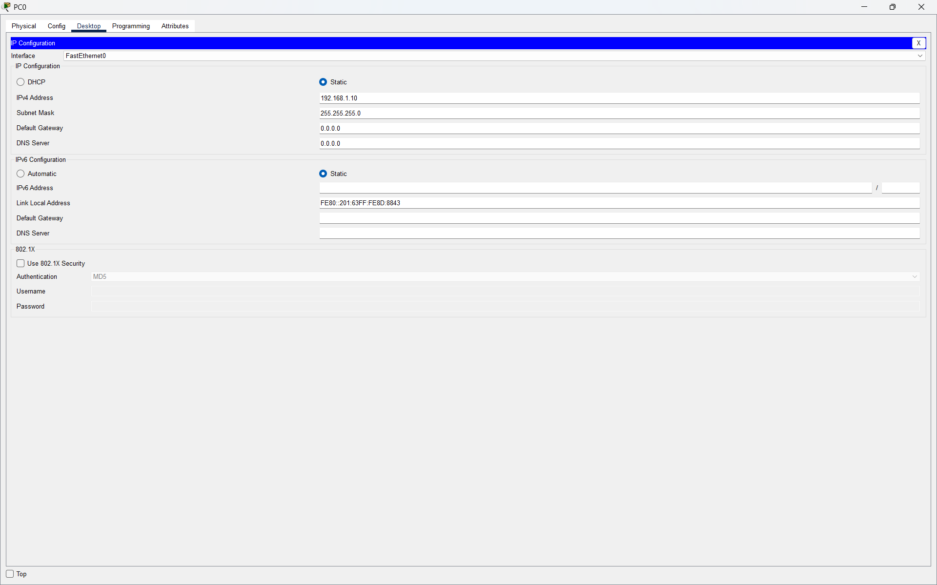
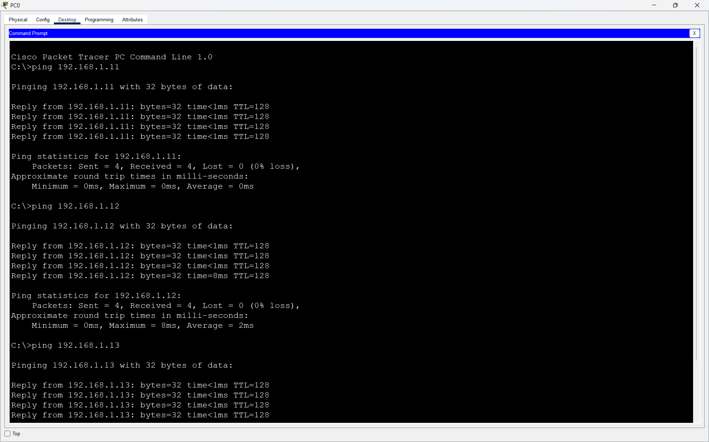

Q2. Set up a DHCP server (using your router or software like Packet Tracer/GNS3/VirtualBox) to automatically assign IP addresses to at least three devices, and confirm that each device receives a unique IP from the correct range?

Answer
- A DHCP server was configured to automatically assign IP addresses to three PCs. The DHCP pool started from 192.168.2.10 with subnet mask 255.255.255.0. Each PC received a unique IP address from the configured range, confirming that DHCP was working correctly.
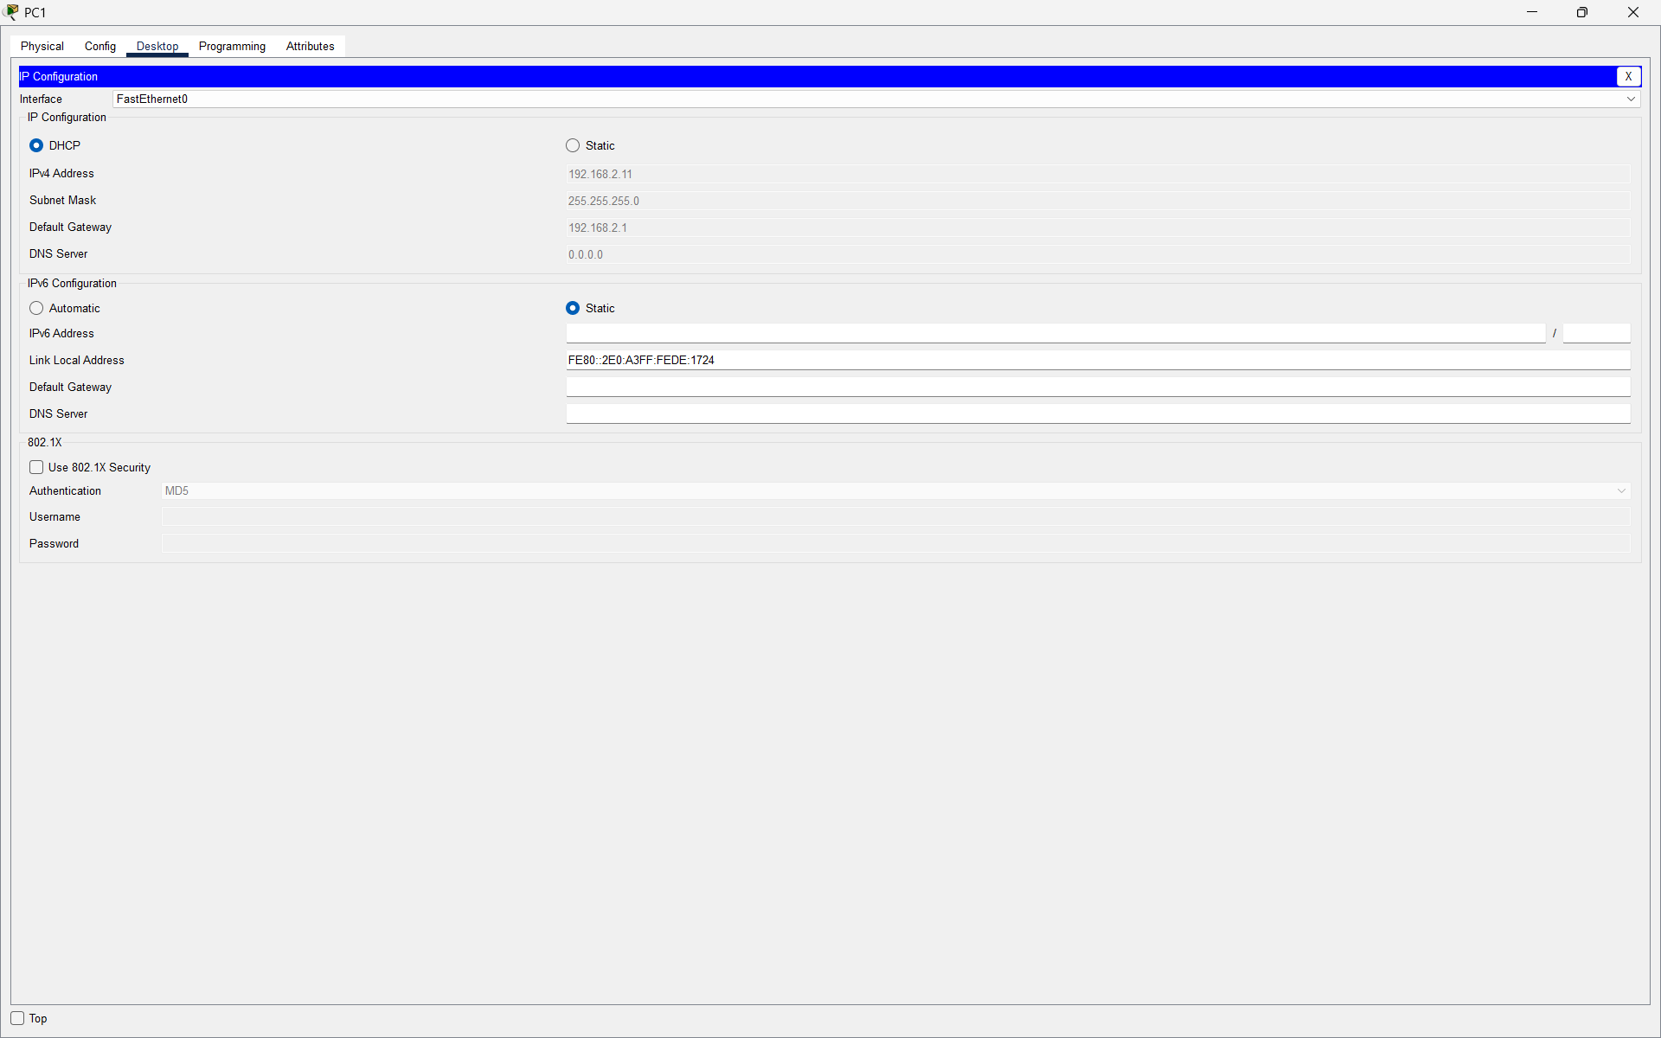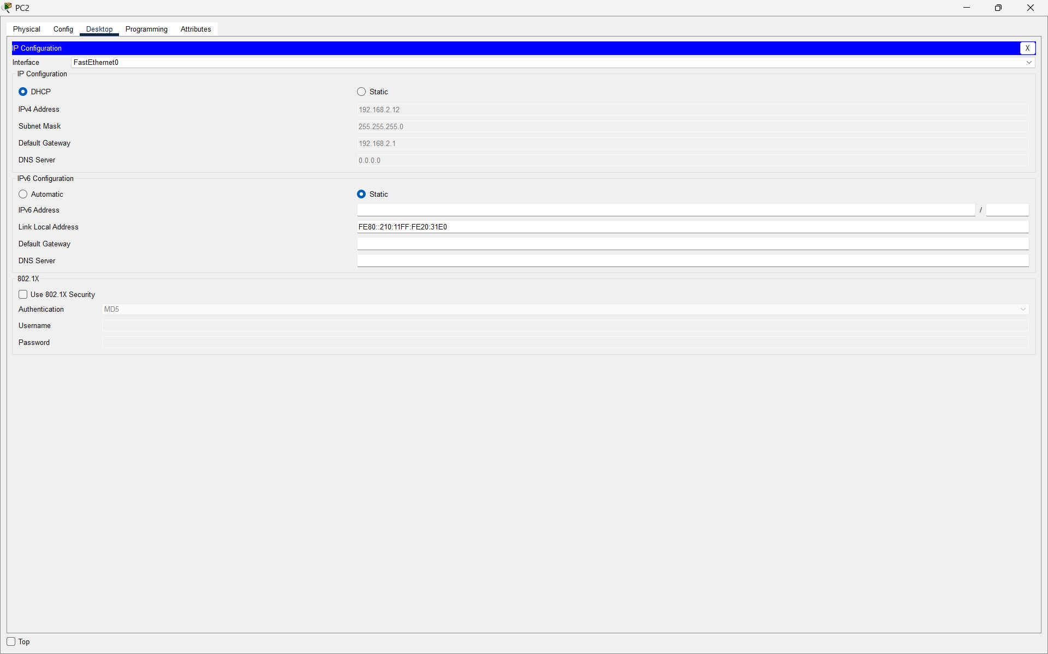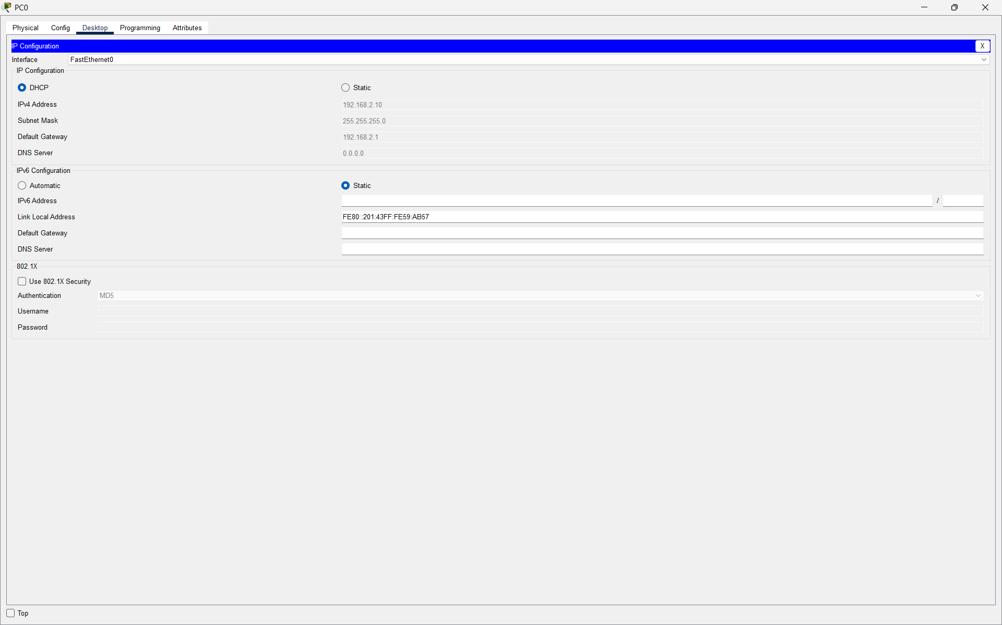

Q3. Configure a DNS service (using your router’s DNS settings or a tool like dnsmasq) so that typing a custom hostname (e.g., musicplayer.local) in a browser on any connected device opens a specific local web page or device interface.<br><br><em><strong>Hint:</strong> You can map hostnames to local IPs using the DNS service or by editing the hosts file for a quick test.</em>?

Answer
- A DNS record was configured to map musicplayer.local to the local server IP 192.168.2.2. The client PC used this DNS server, and entering musicplayer.local in the browser successfully opened the local web page.
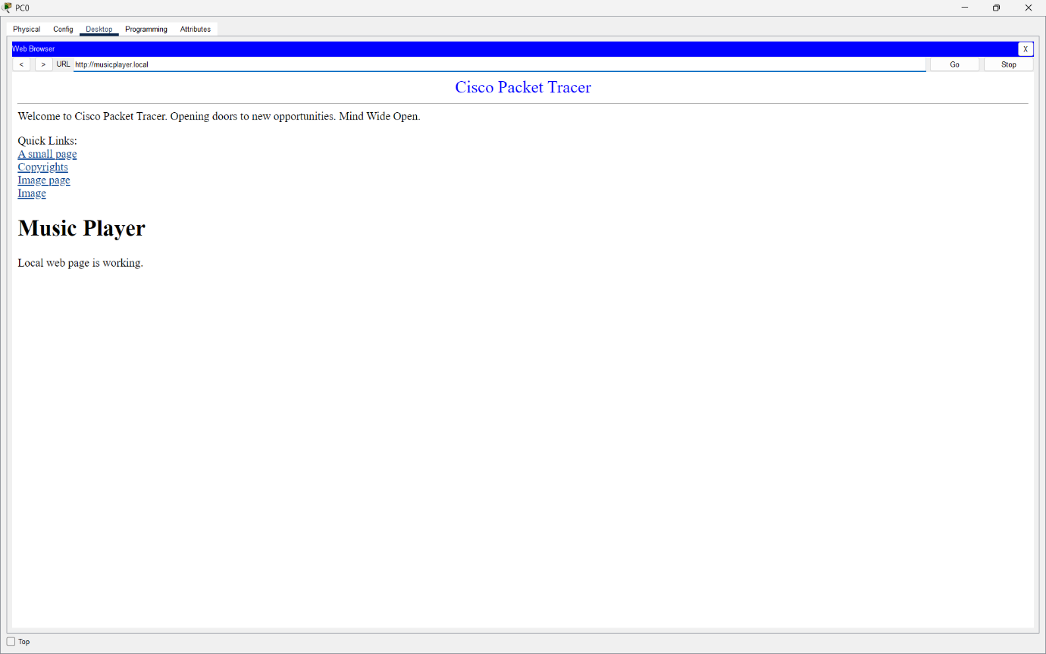
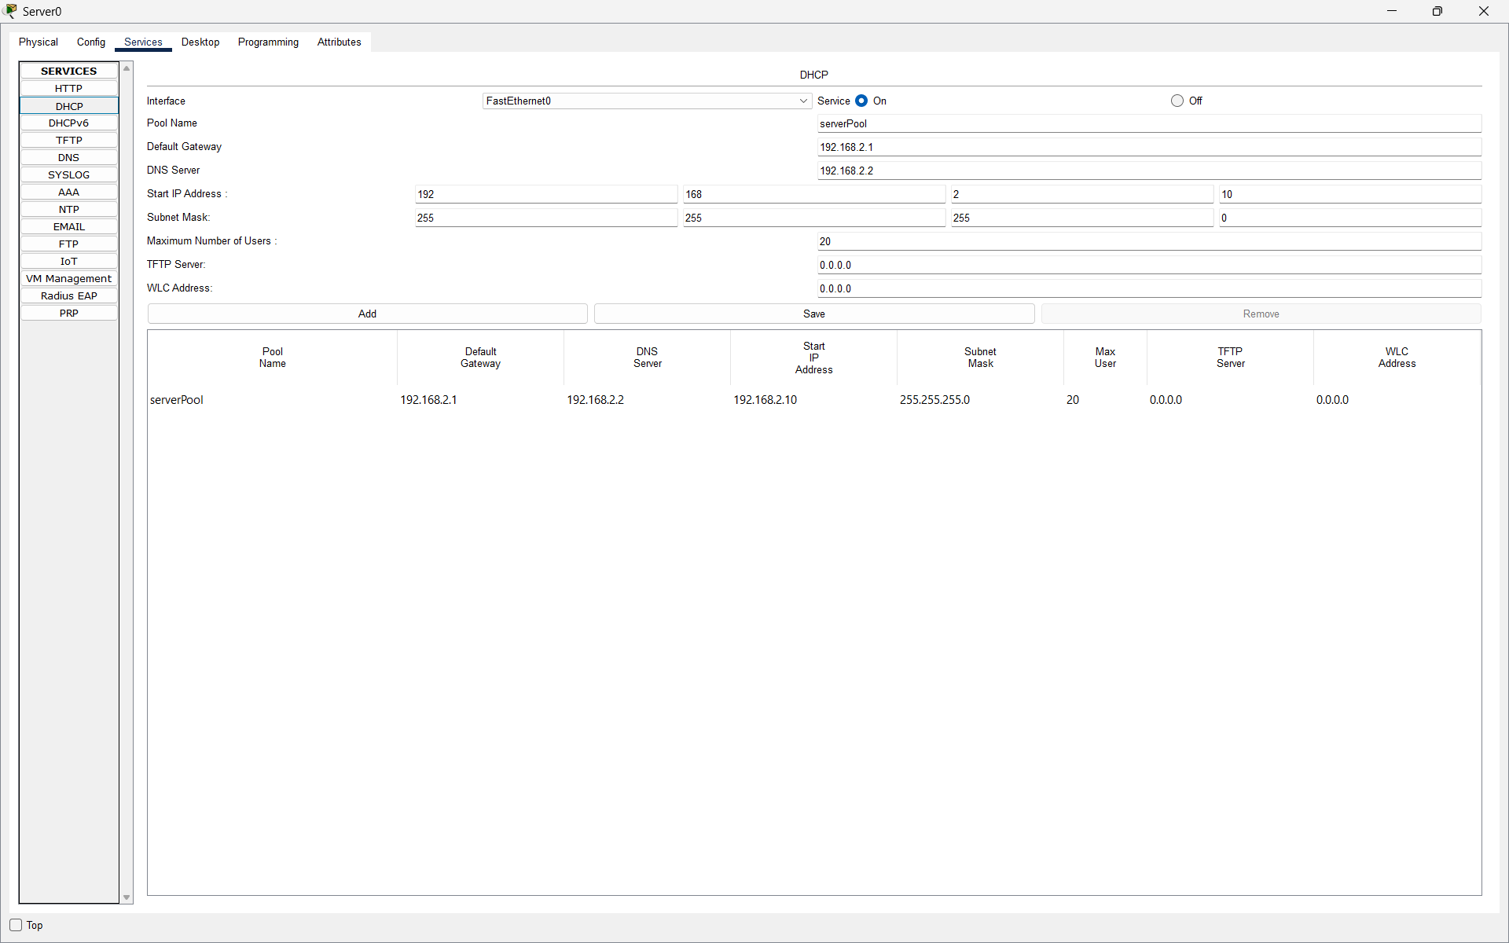

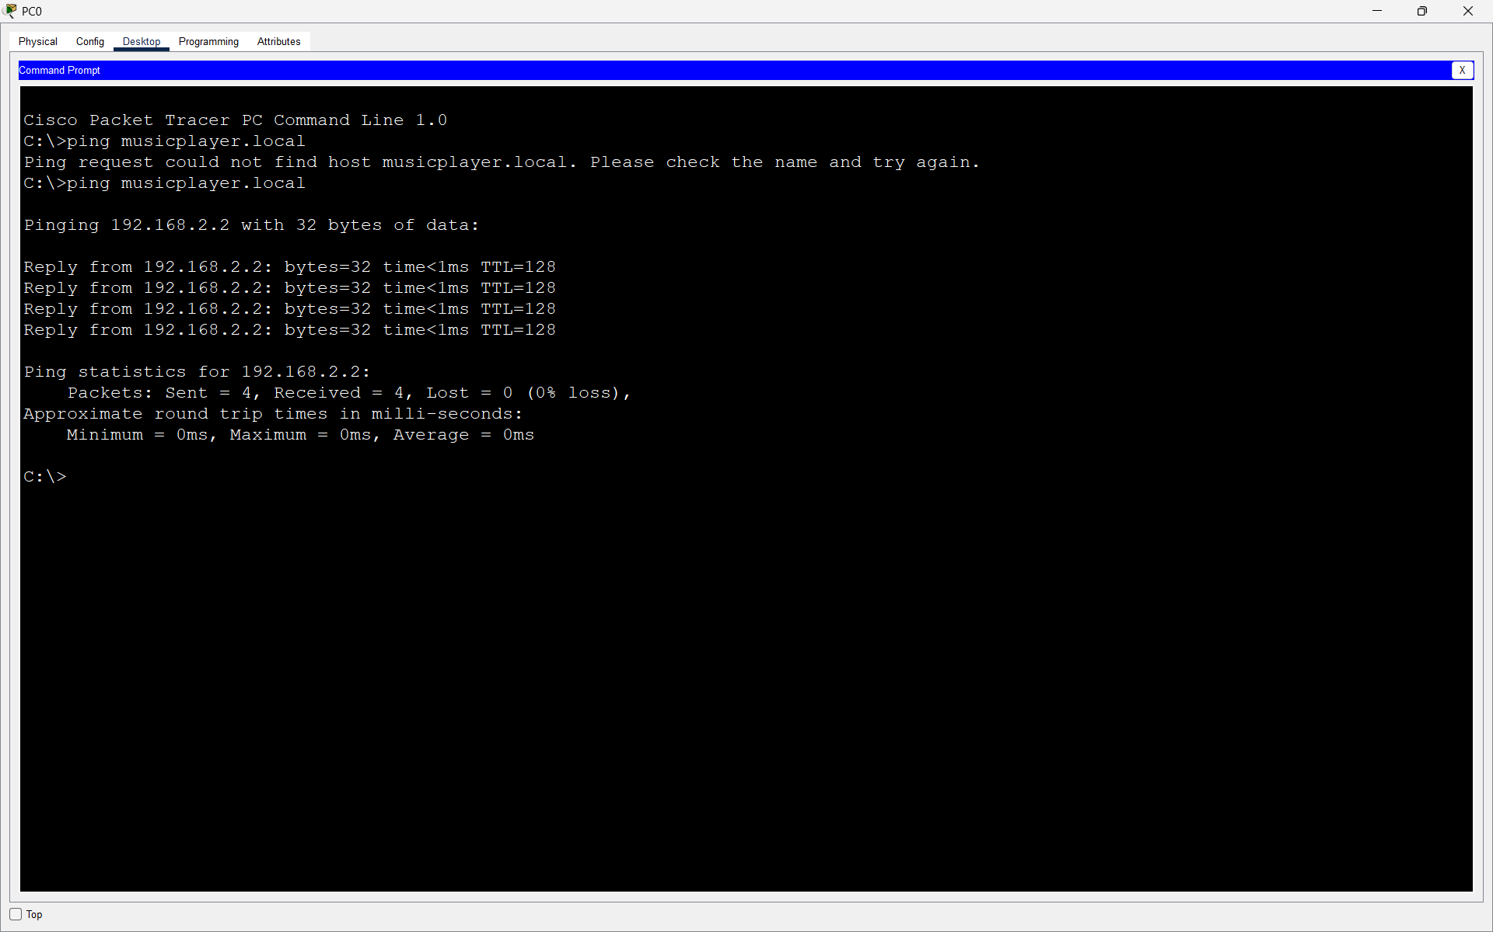

Q4. Create two VLANs (e.g., VLAN 10: 'Workstations', VLAN 20: 'Smart Devices') on your switch or simulation tool, assign at least two devices to each VLAN, and demonstrate that devices in the same VLAN can communicate, but not with devices in the other VLAN.<br><br><em><strong>Hint:</strong> Use ping or file sharing to test connectivity between devices in different VLANs.</em>?

Answer

- Two VLANs were created: VLAN 10 (Workstations) and VLAN 20 (Smart Devices), with two PCs assigned to each VLAN. Devices in the same VLAN communicated successfully using ping, while communication between VLAN 10 and VLAN 20 failed because inter-VLAN routing was not configured.
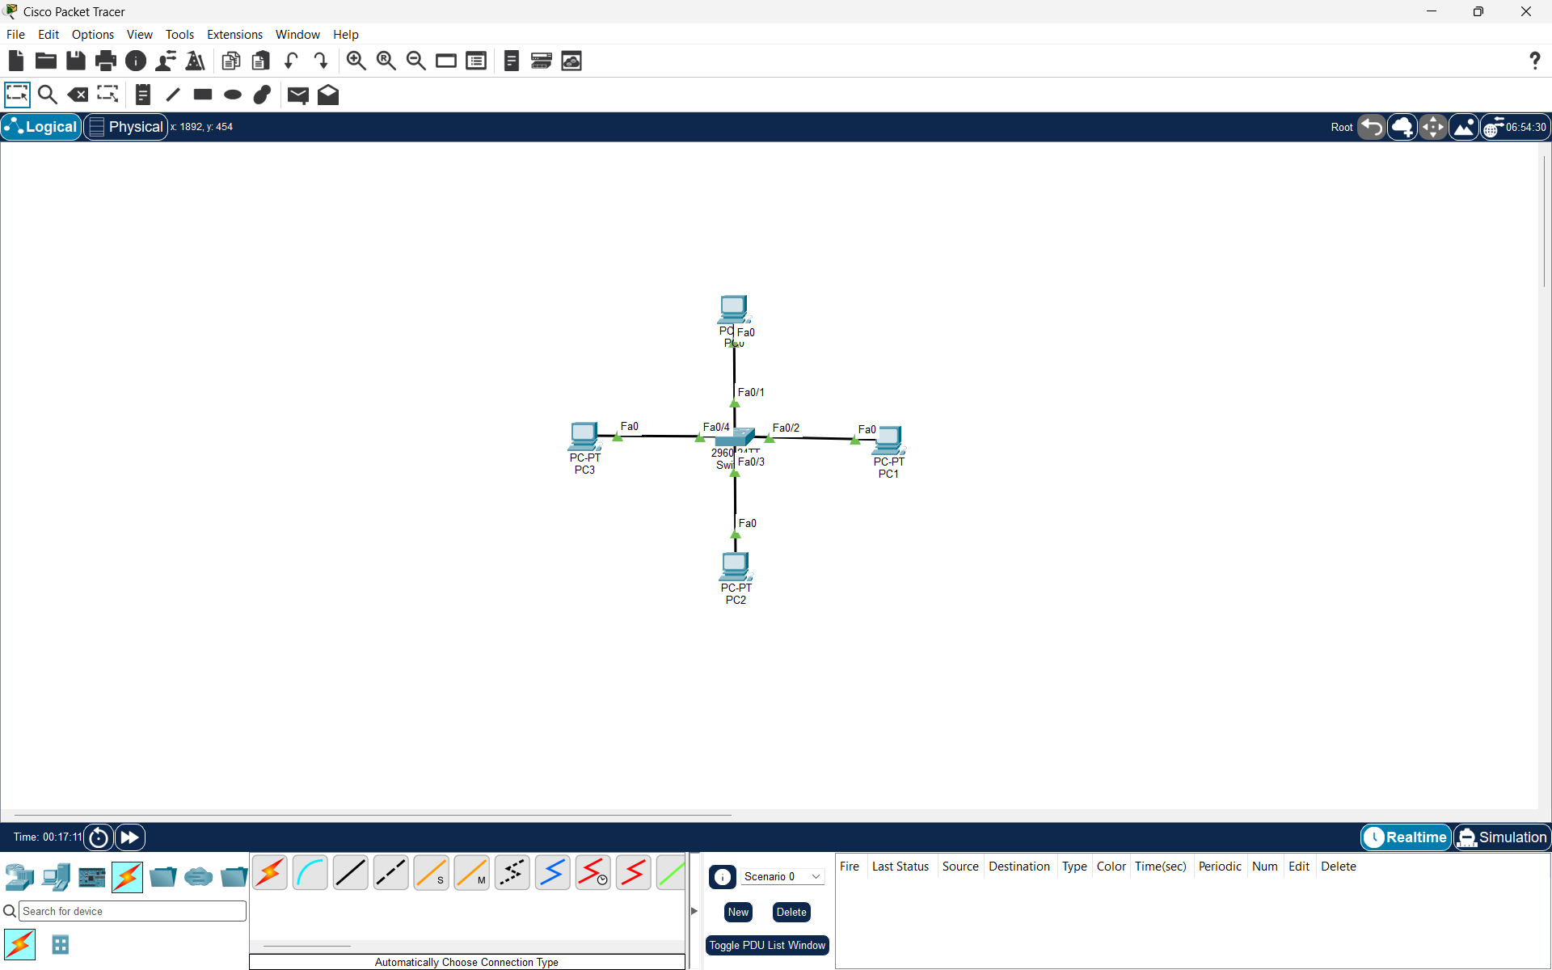
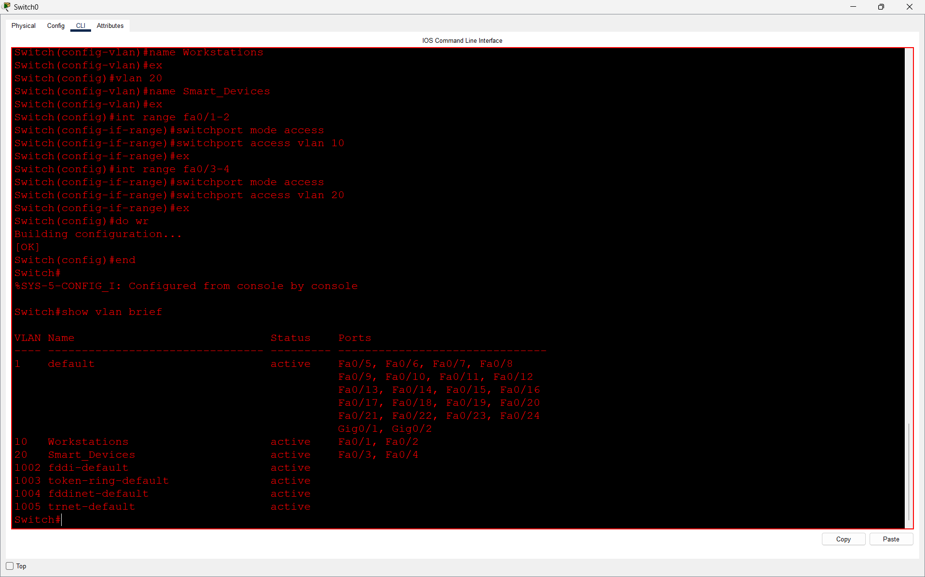

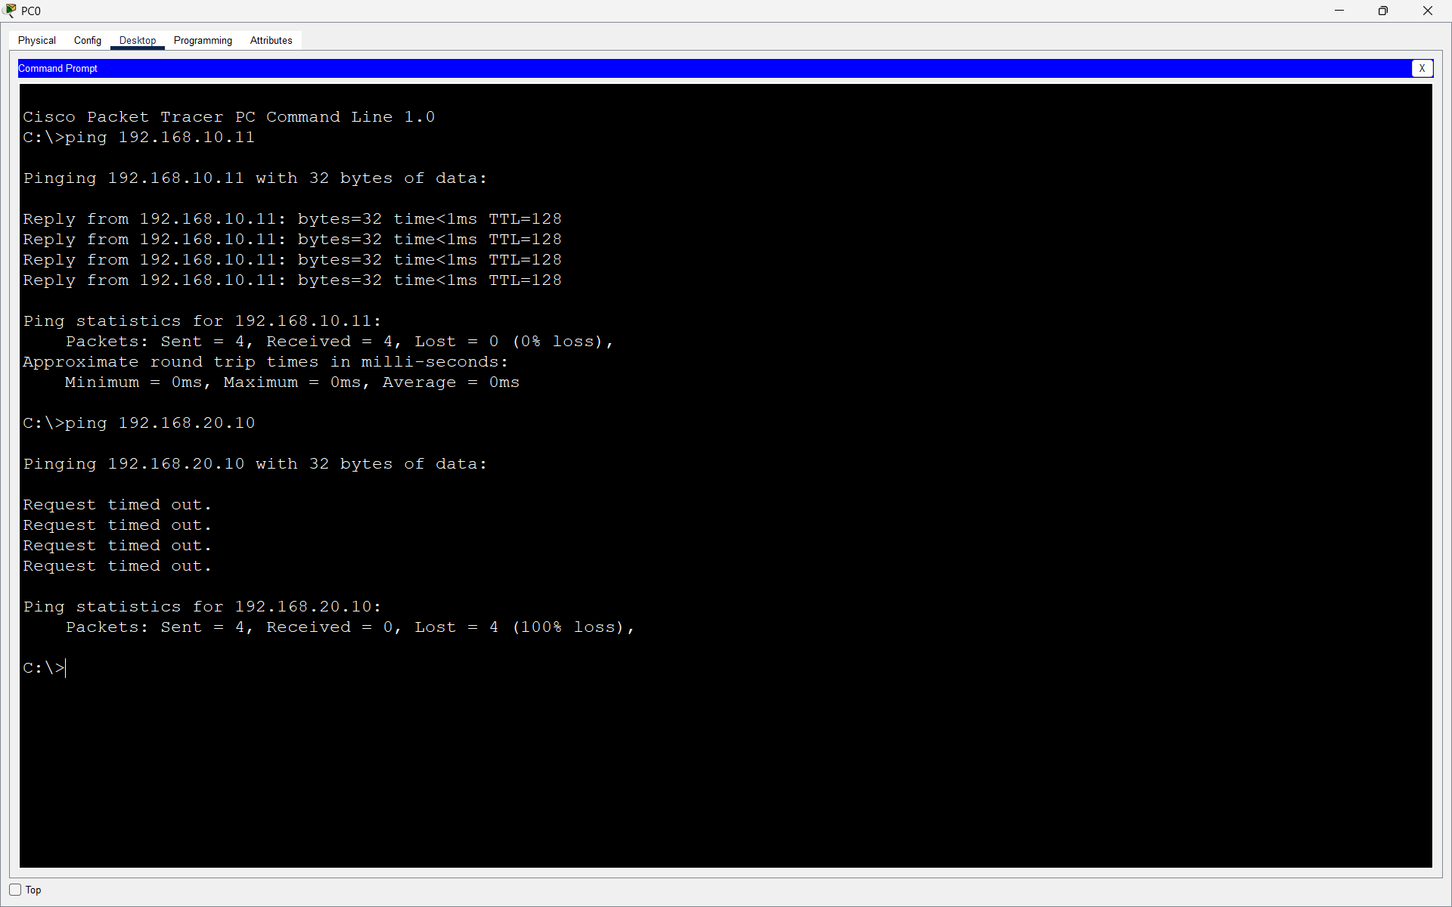

Q5. Simulate internet access for your LAN by configuring a router with NAT (Network Address Translation), then test that devices on your LAN can access an external site (e.g., www.wikipedia.org) or a simulated external server?

Answer
- NAT was configured on the router to allow the private LAN network to access the simulated external network. NAT overload was used, and connectivity was verified by successfully pinging the external server 8.8.8.8. The NAT translation table confirmed that address translation was working correctly.

